OS Lab 3: Shell Scripting part 2

* Pre-defined Variables
* Command line arguments
* Control structures
* Loops

Variables:

* 1. User defines
  2. Environmental variables
  3. Pre-defined

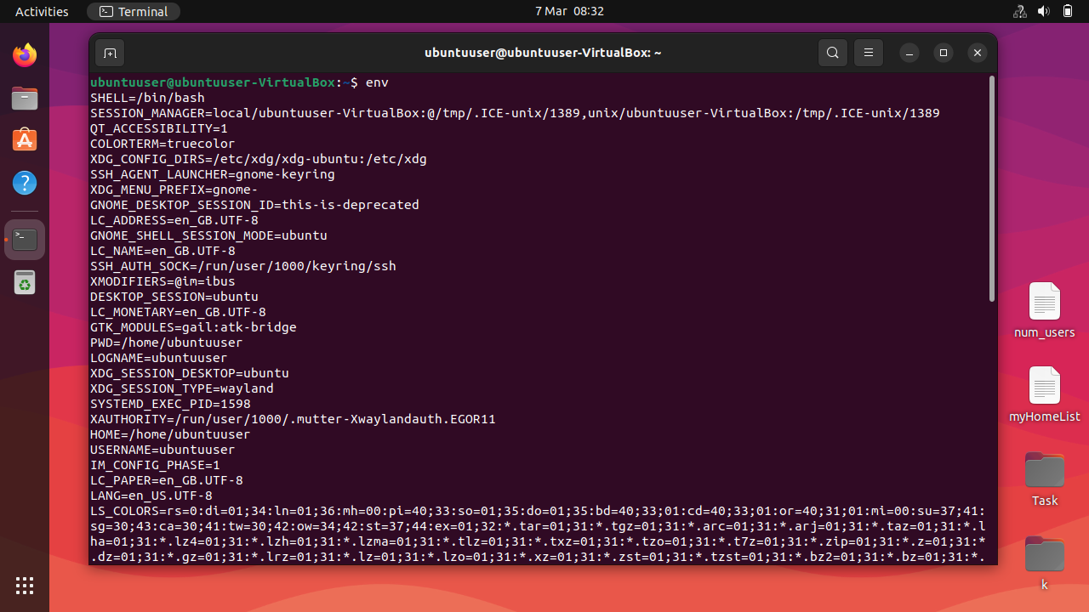Following is the screenshot of environmental variables of bash shell. One of them is PATH variables which stores the path of executable files.

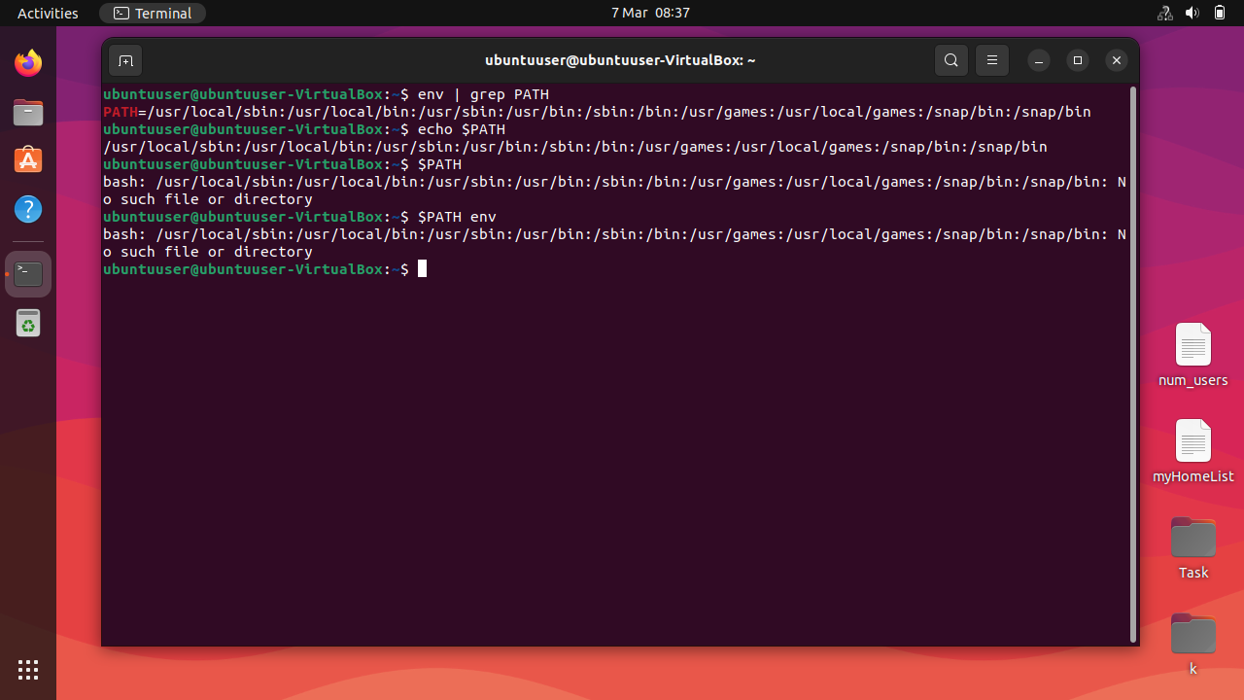

**Command line arguments:**

Arguments passed to the command.

e.g Ls -l: ls is command and -l is command line argument.

**Shell Pre-defined Variables:**

**Following are the pre-defined variables in bash shell**

$#: shows no of command line arguments.

$*: lists all of the arguments.

Use shift command and then use $* CLA.

$0: stores the name of executables.

**Control Statements:**

**If/Else:** if [condition] then statements 1,…,statements n

**Else if:** else if [condition] then statements 1,…,statements n else then statements 1,…,statements n fi

**Switch:** case:

case myvar in:

1. statements 1,…,statements n
2. statements 1,…,statements n

…

*) statements 1,…,statements n note: * is for default:

Use ;;(double semi colons for case endings)

esac (for ending switch).

**Loops:**

**While:** while [ condition ]

do

statements 1,…,statements n

done

**For Loop:**

for I in $*

do

statements 1,…,statements n

done

**Until:**

Until [ condition ]

do

statements 1,…,statements n

done